**SCREENSHOTS**

**HOME**

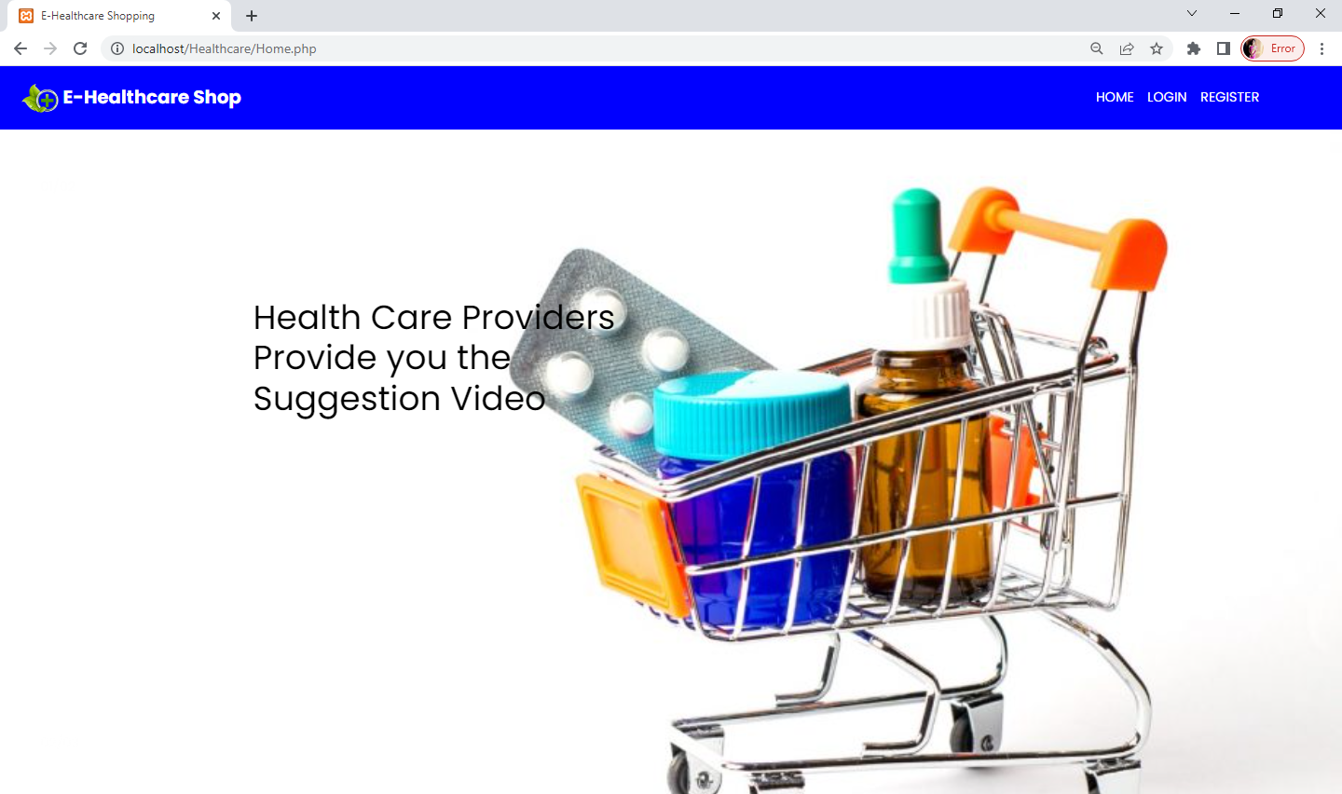

**ADMIN LOGIN:**

**USERNAME:admin123@gmail.com**

**PASSWORD:Admin**

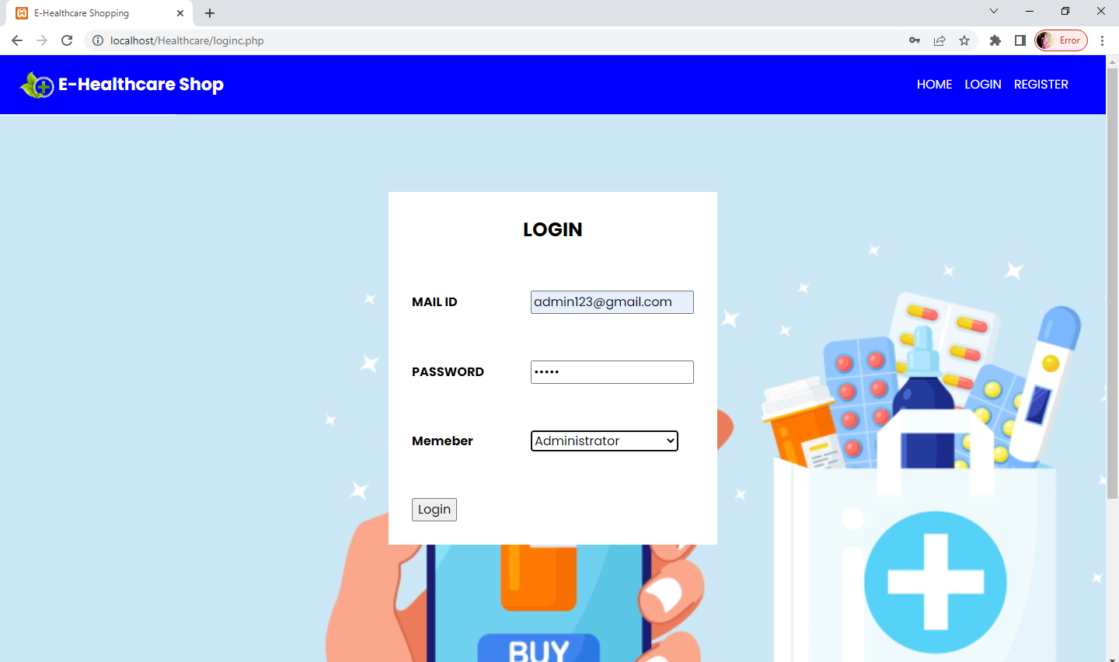

**ADMIN HOME:**

**ADD CATEGORY:**

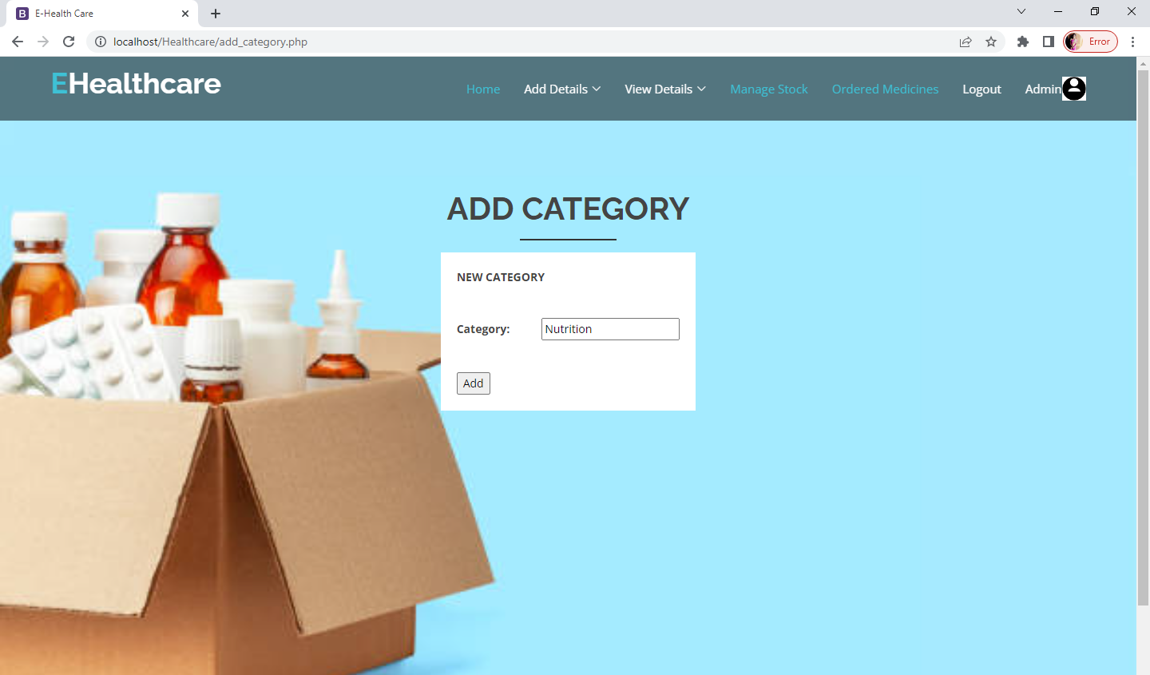

**ADD MEDICINE:**

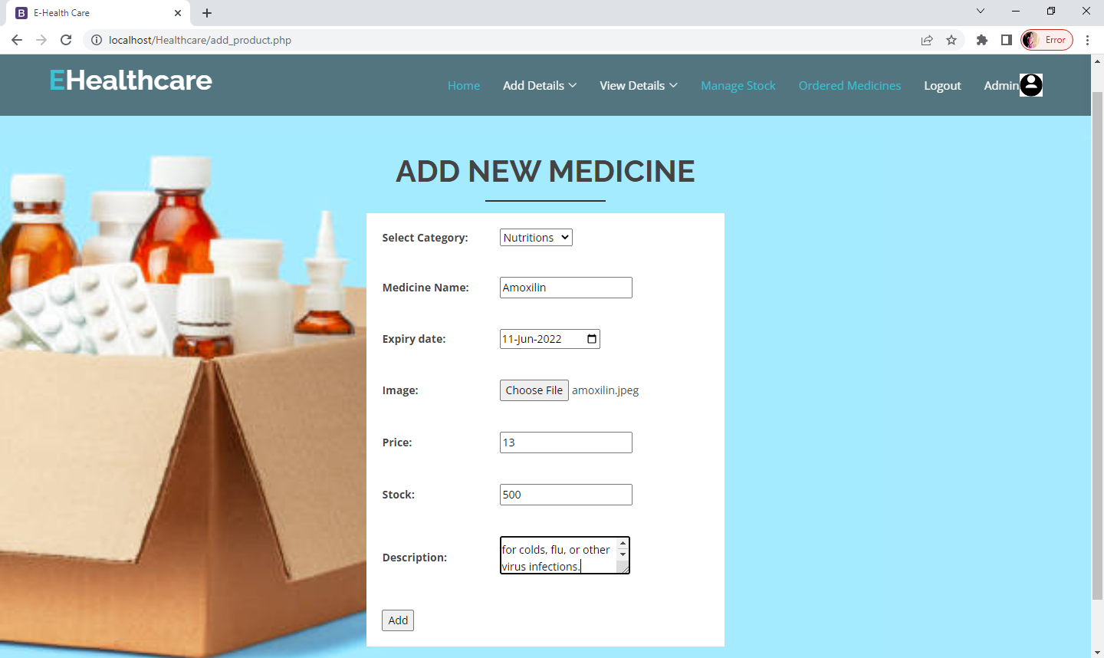

**ADD DISEASE:**

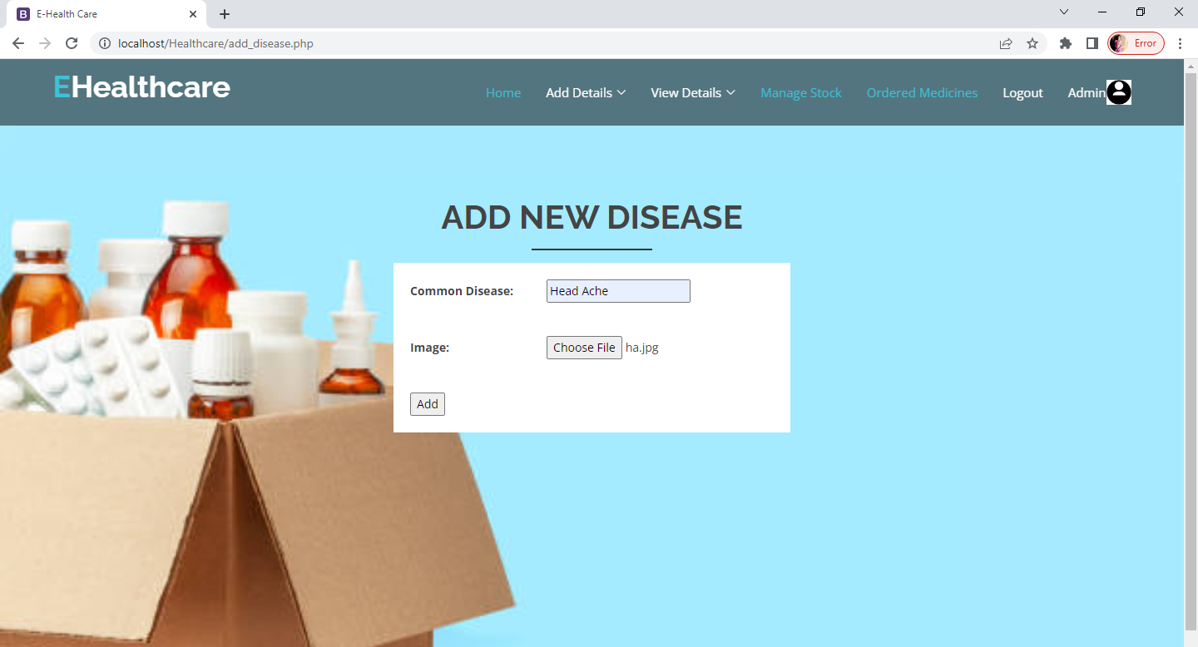

**HEALTH CARE PROVIDER REGISTRATION:**

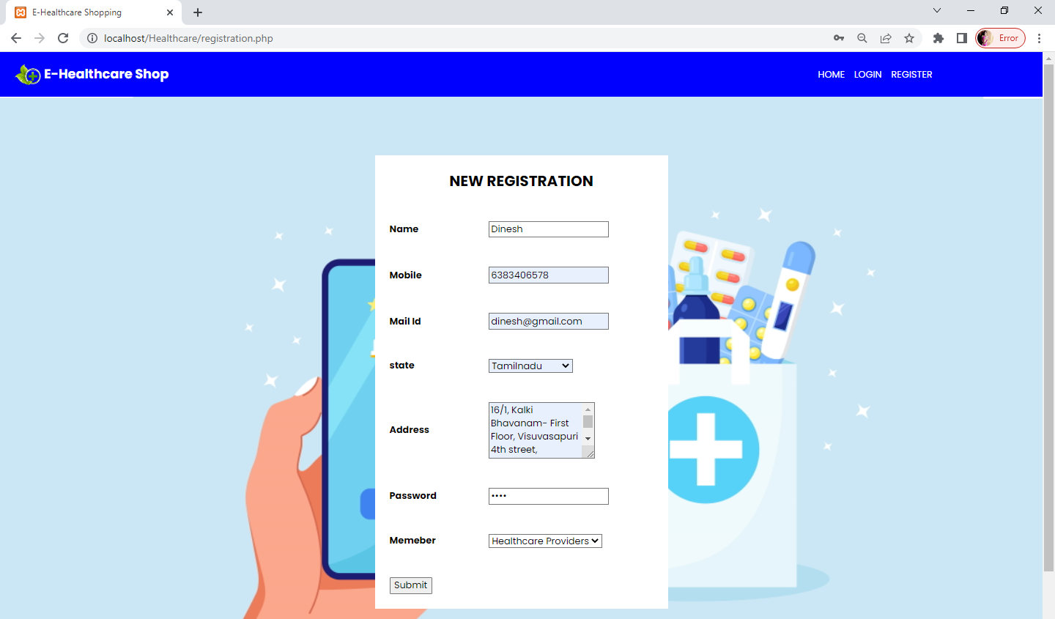

**CUSTOMER REGISTRATION:**

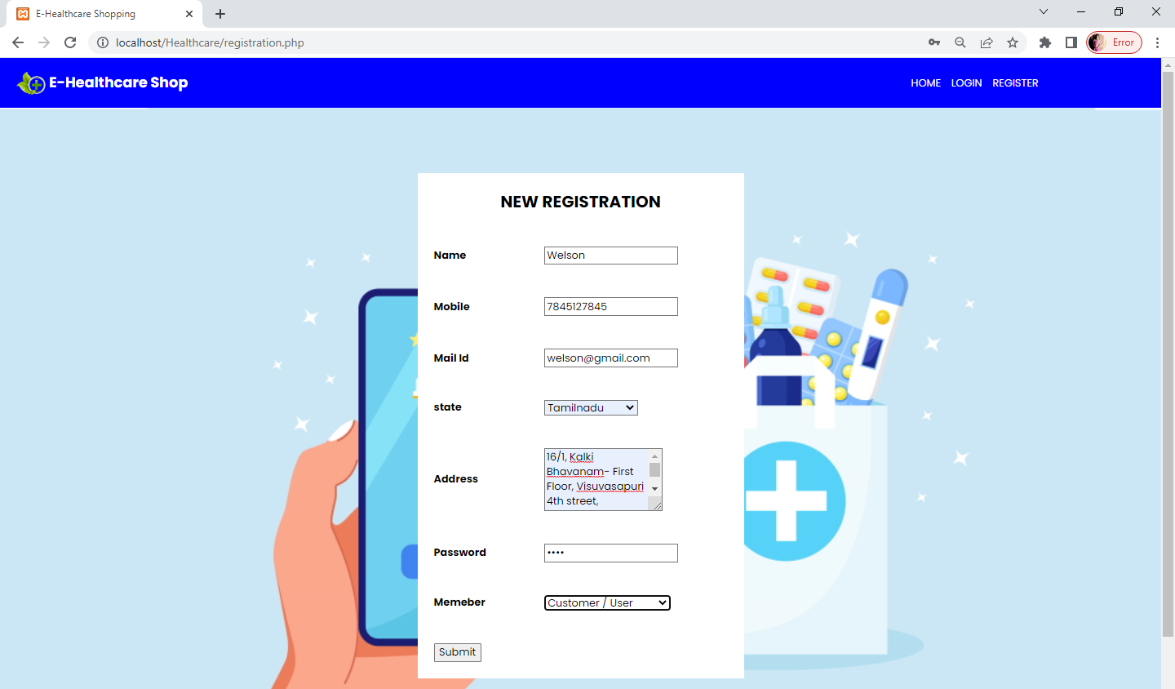

**HEALTH CARE PROVIDER LOGIN:**

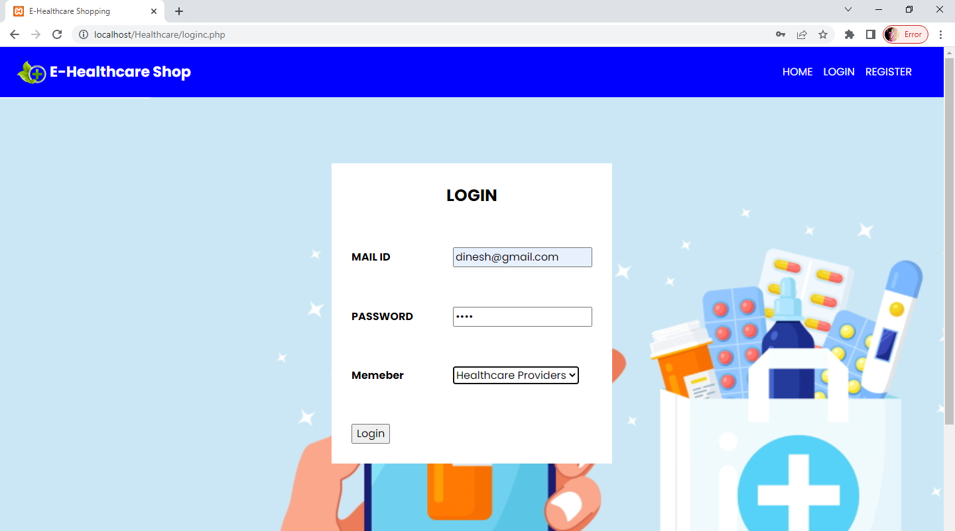

**HEALTH CARE PROVIDER HOME:**



**ADD VIDEO:**

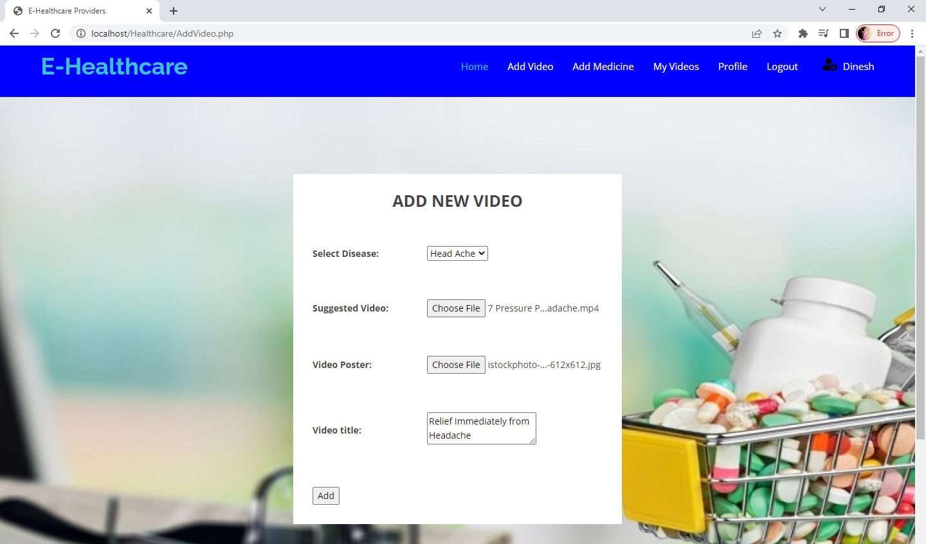

**VIEW MEDICINE**

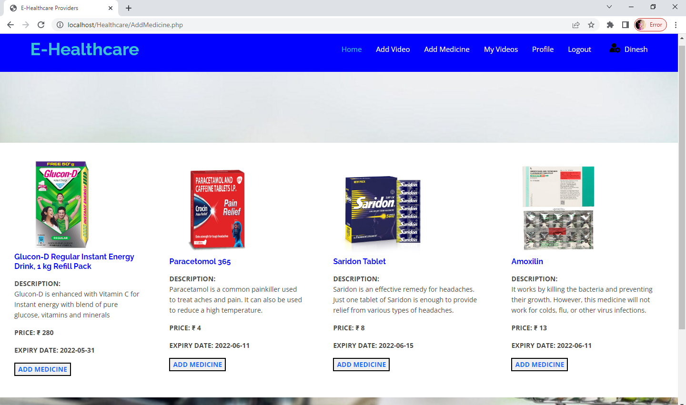

**ADD MEDICINE TO YOUR VIDEO**

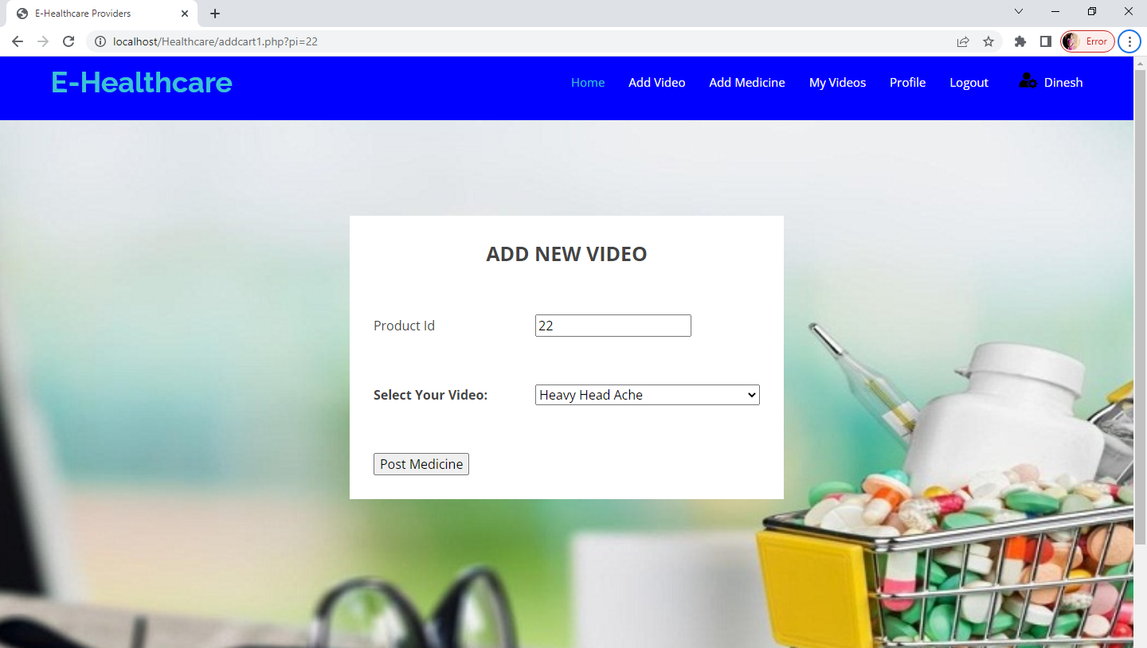

**VIEW MY VIDEOS**

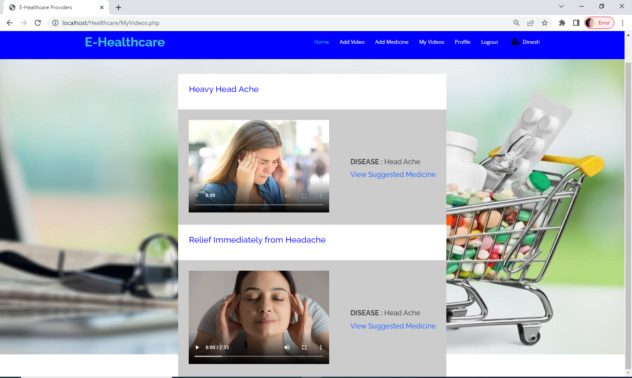

**VIEW SUGGESTED MEDICINE**

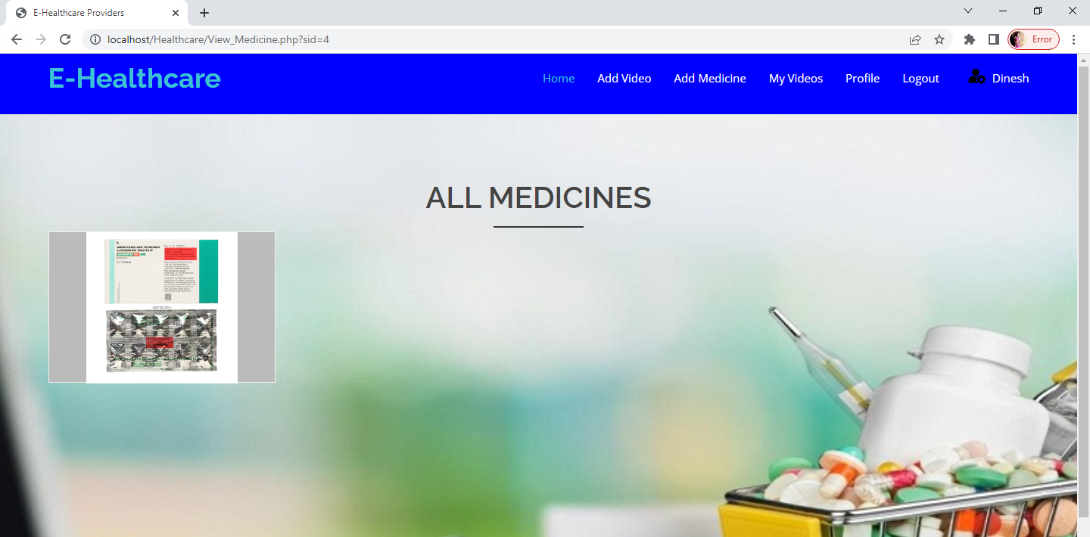

**VIEW PROFILE:**

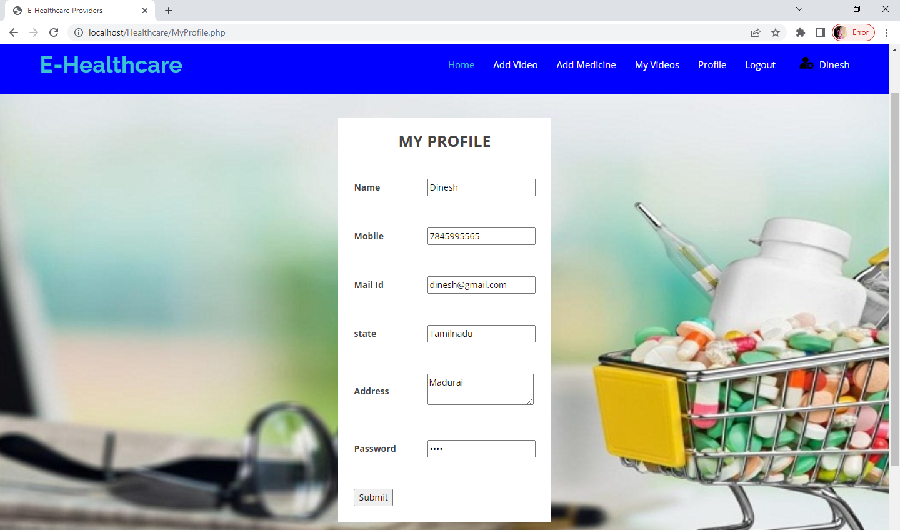

**CUSTOMER LOGIN:**

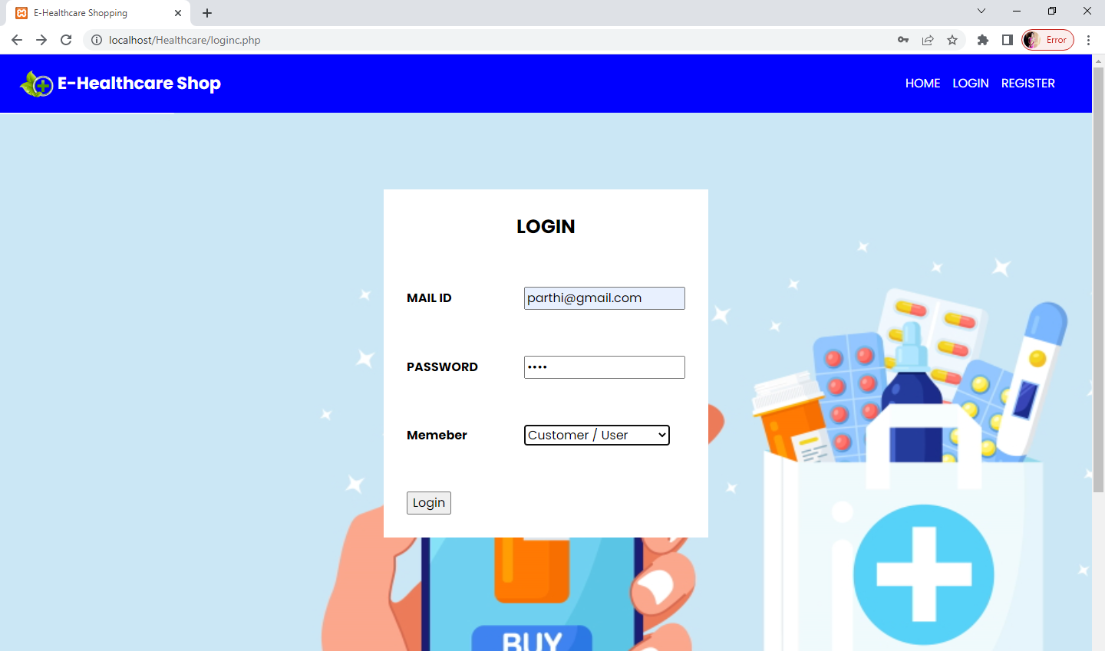

**CUSTOMER HOME**



**SEARCH DISEASE**

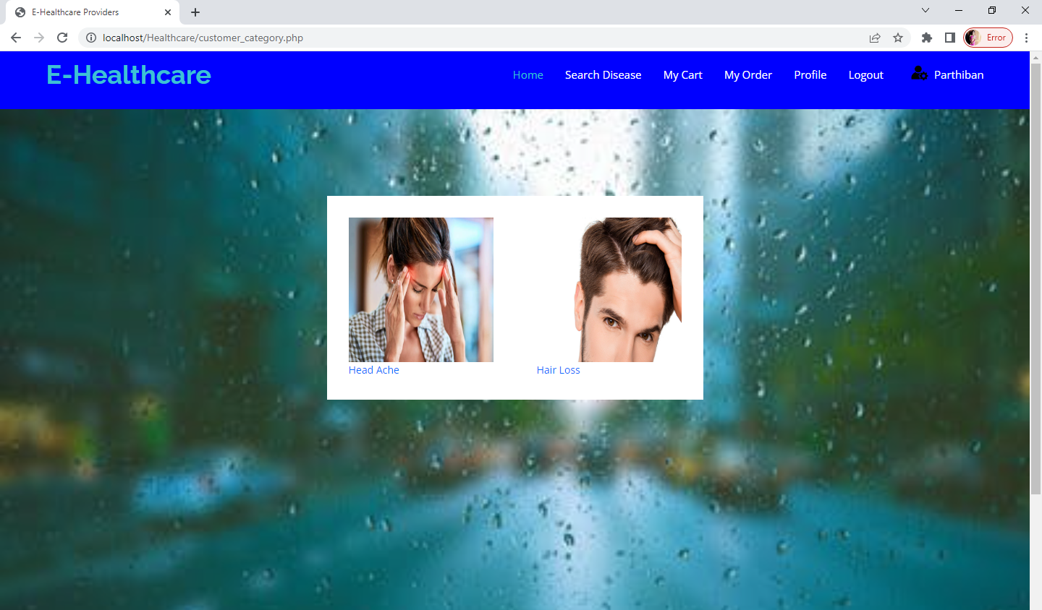

**VIEW SUGGESTED VIDEO**

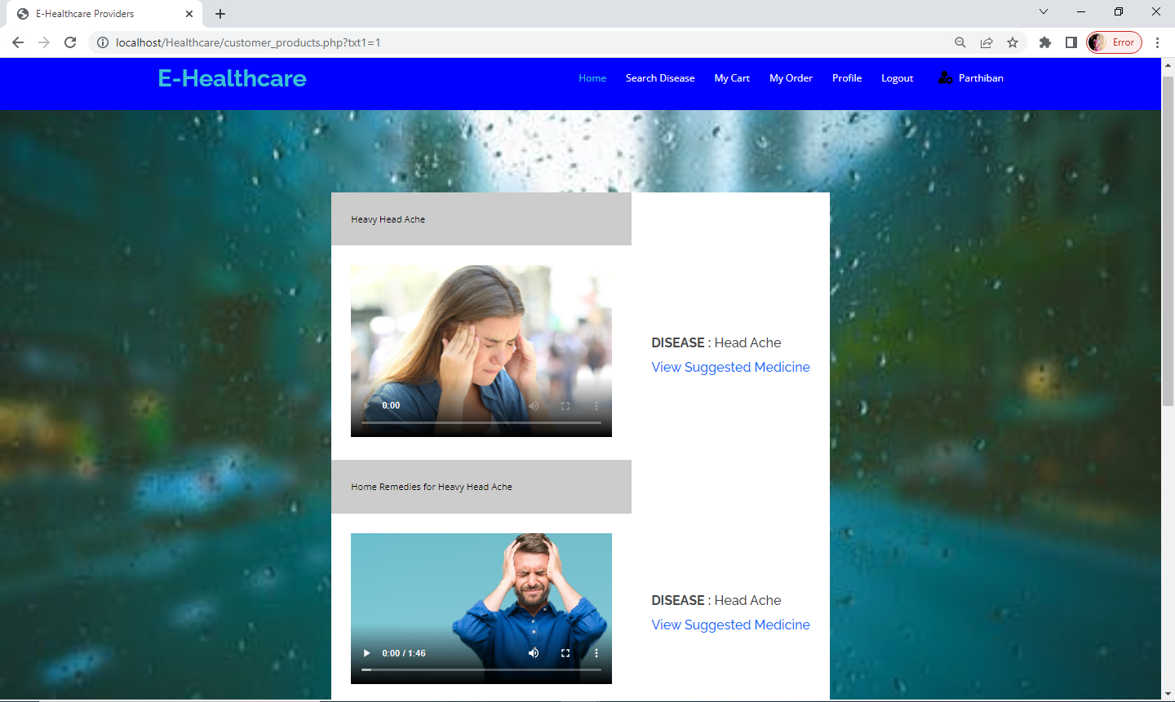

**VIEW SUGGESTED MEDICINE:**

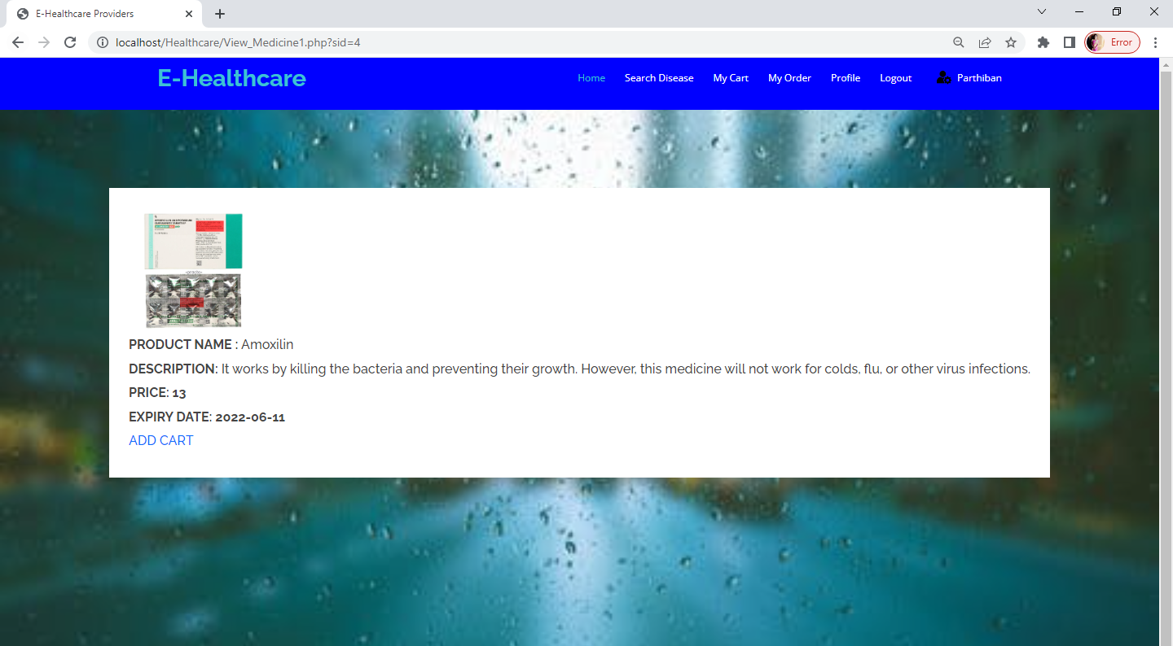

**ADD TO CART**

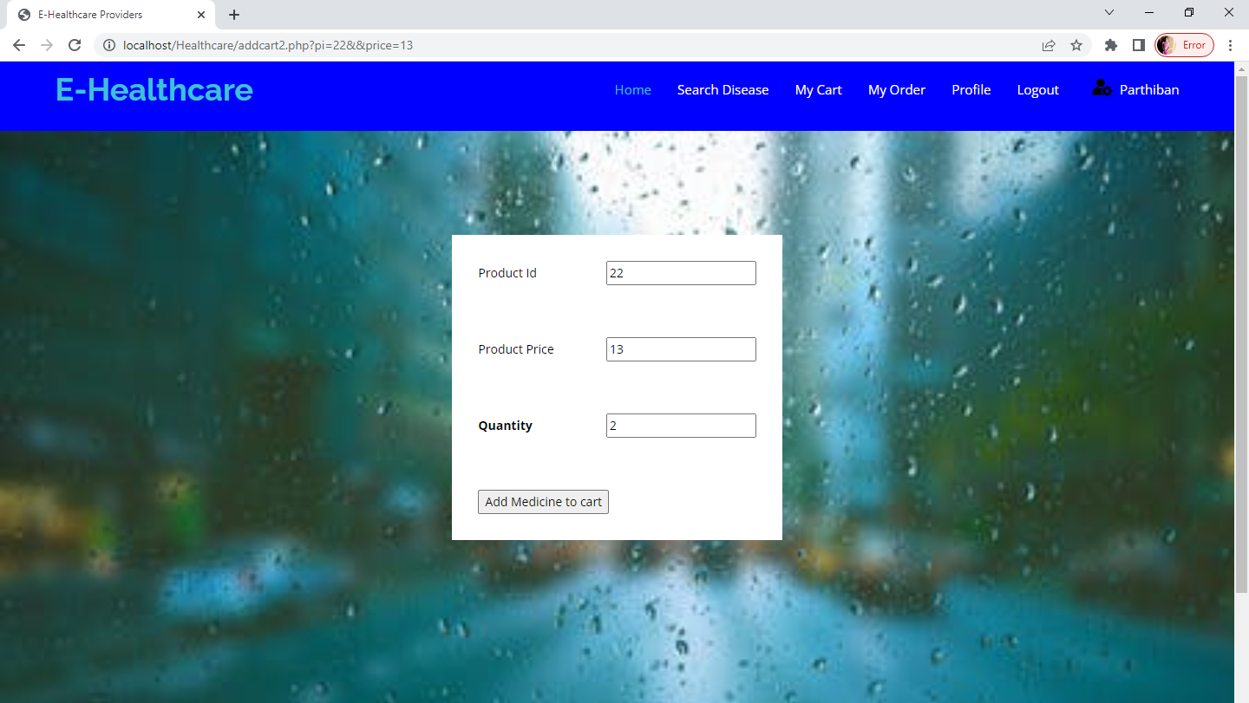

**BUY**

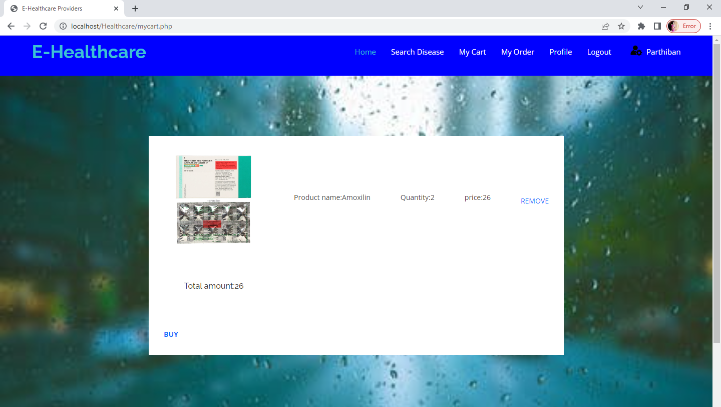

**MY ORDERS:**

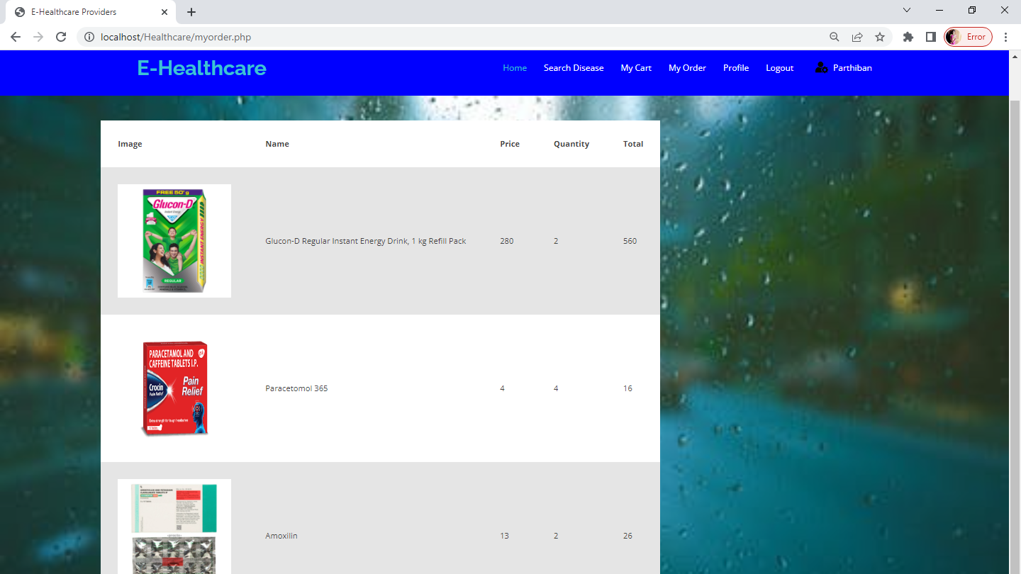

**ADMIN LOGIN AND VIEW ALL CUSTOMER:**

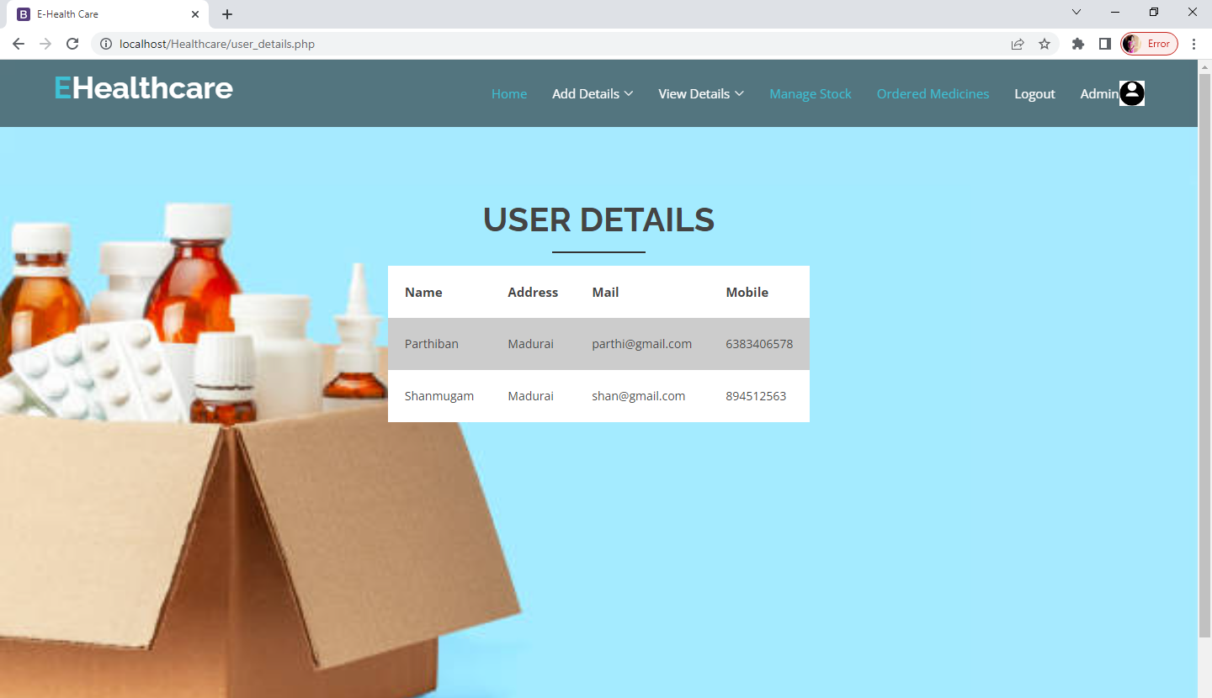

**ALL HEALTH CARE PROVIDERS**

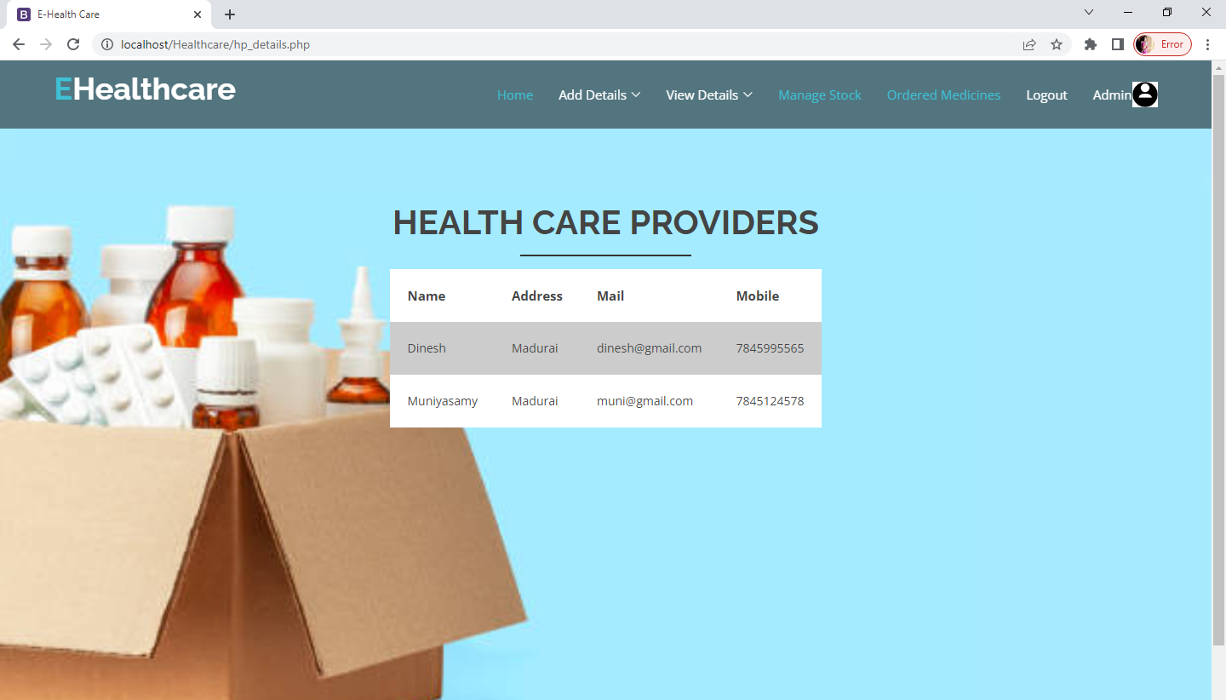

**ALL ORDERED MEDICINE:**

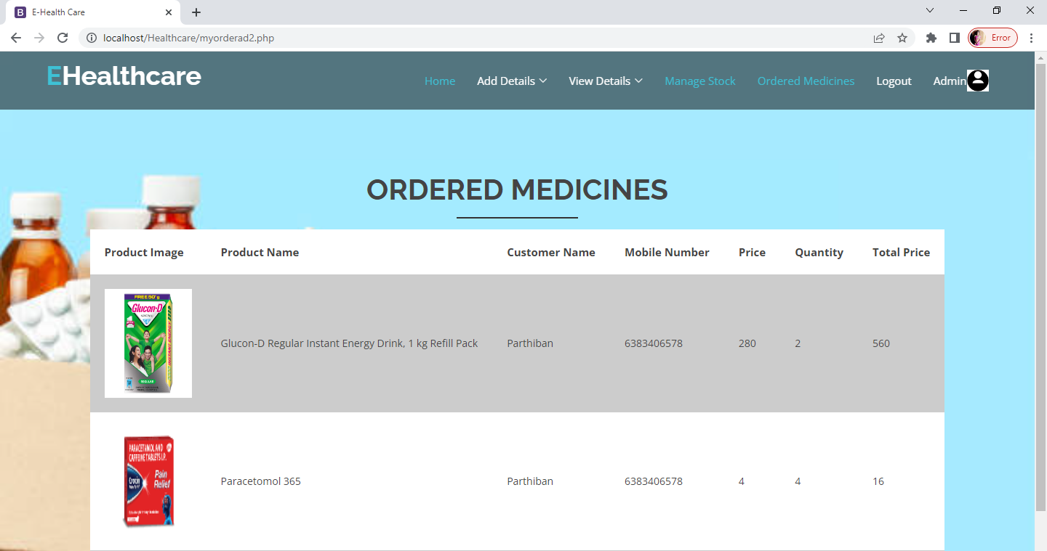

**MANAGE STOCK**

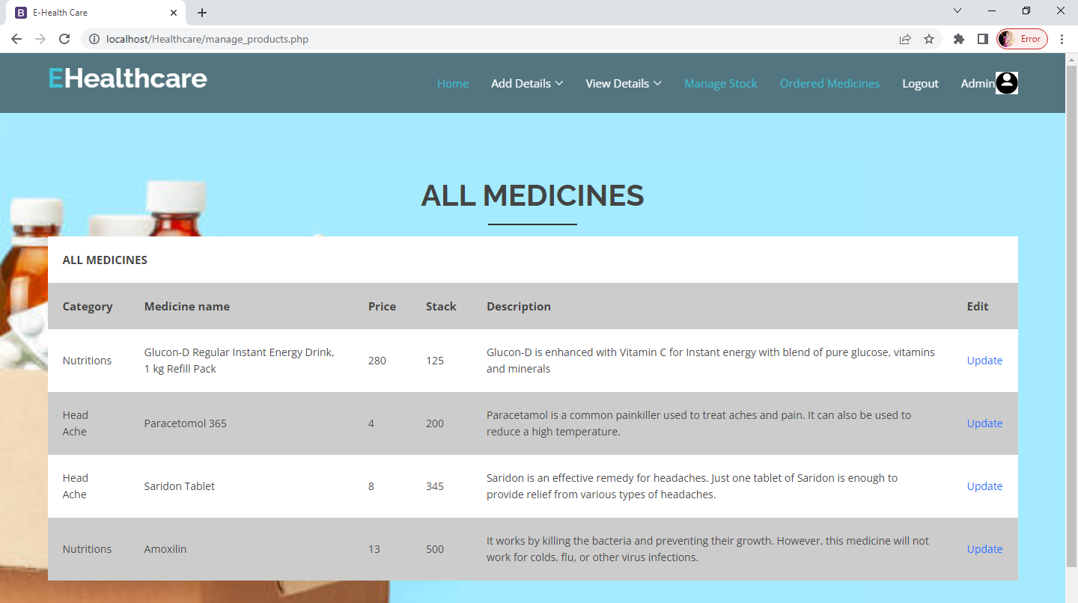

**UPDATE STOCK**

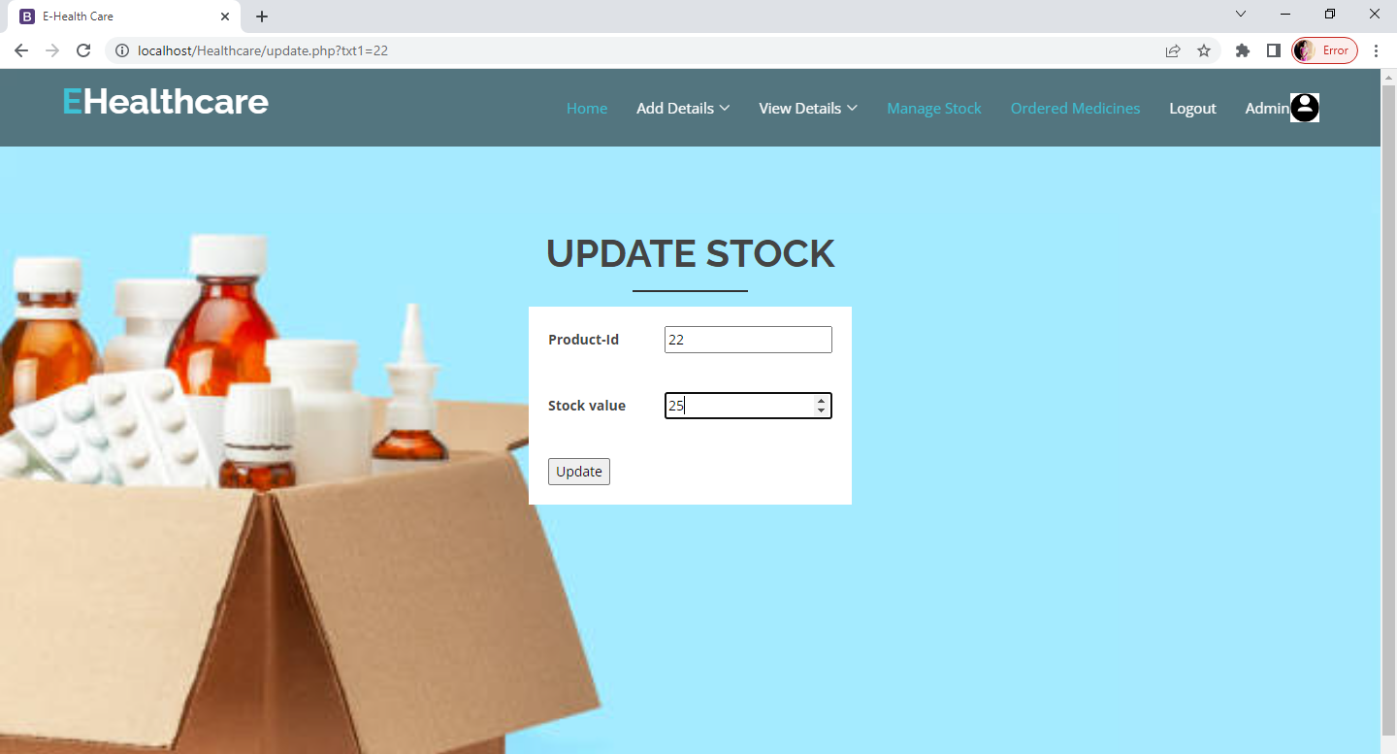

**VIEW ALL DISEASE:**

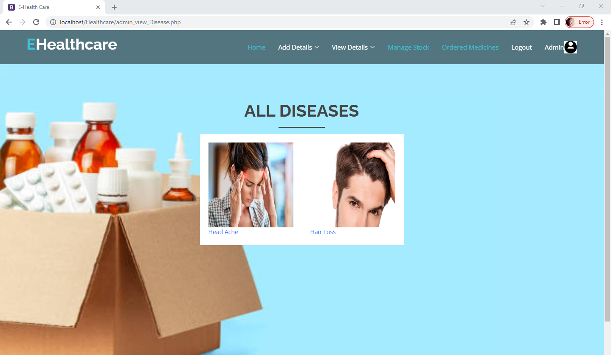

**VIEW ALL VIDEOS**

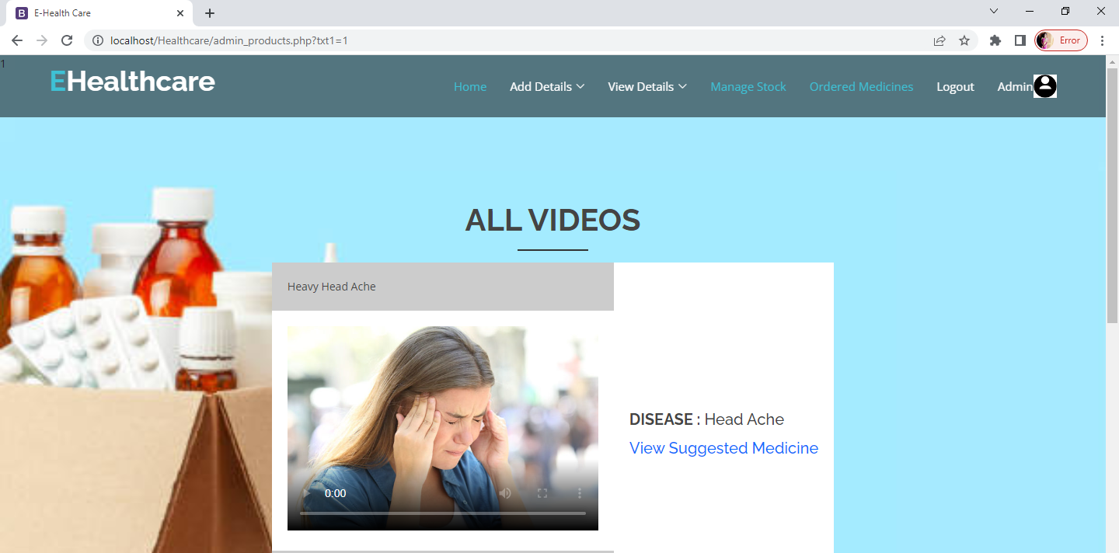

**VIEW ALL SUGGESTED MEDICINE:**

